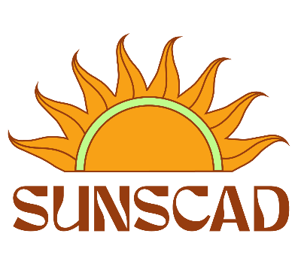
_________________________________________________________________________________________________

Council Meeting

Date: Feb 6 2023
Room: Online
Time: 5:00pm

Agenda:
Reports
Strike Constitution Committee
Upcoming Events

1. Call to Order 5:14 pm

Opening remarks from Tara Fleming. Recognizing we are situated on unceded and unsurrendered Mi’kmaq territory, which is covered under the Peace and Friendship Treaties since 1725. It is our responsibility to understand our relationship with the land as stewards, arrivants, and settlers.

2. Present:
Beah, Chris, Owen, Julian, Alexina

Regrets: none

3.Chris motions to approve the agenda, Alexina seconds: Unanimous, motion passes
4. Chris msotion to approve last council minutes, Julian seconds: Unanimous, motion passes

Signatures:

____________________________ _________________________
President Resource Coordinator

Reports:
Beah
- Attended working and exec meetings
- Worked on SUNSCAD Instagram
- Attended the SUNSCAD Finance meeting
- Research booking the oval for skating
- Met with Aaron Langille to talk spring market
Chris
- Attended working and exec meetings
- Organising the office
- Attended the BOG committee meetings
- Went to the BOG workshop
- Working on Equity workshop to look at rebates for students
Constitution Committee:
- Chris motions to strike to Constitution Committee to start working on the Bylaws, Alexina seconds, unanimous, motion passed
Upcoming Events:
- Skating
- Town Hall
- Elections
- Spring Market (April 15th) – Vendor application form coming out Feb 17th
- Equity Workshop
- March Coffee/Café March

Announcements
- Design would like help with publicizing

Chris motions to adjourn, Alexina seconds, unanimous, motion passed. Meeting ends at 5:32pm

Next Council meeting time : Feb 20th at 5pm.

